**Table of Contents**

Introduction……………………………………………………………………………………………………………………………Page 1

Able Body Report Roster (A.B.R.R.) Features…………………………………………………………………………..Page 2

Duty Roster Features………………………………………………………………………………………………………………Page 5

Using the Able Body Report Roster (A.B.R.R.)………………………………………………………………….………Page 7

Part 1: Creating the Company Non-Availability Rosters…………………………………………..………..Page 7

Part 2: Importing Rosters and making Calculations…………………………………………………………..Page 7

Part 3: Adjusting the Numbers and Creating the Duty Roster………………………………….………..Page 8

Part 4: Allocating Duty Positions, and Creating and Merging Company Duty Rosters………..Page 9

**Introduction**

The Able Body Report Roster (A.B.R.R.) is an Excel document that was created to ensure fair duty distribution based on percentages and sizes of each company in 8th Communications Battalion, but can easily be adapted to be used by other battalions or companies. This is achieved by evaluating and cross-referencing data from three different accountability rosters. Examples of these documents, their naming standards, and their structure can be found in the “1_EXAMPLES” folder.

By default, the Duty Roster Creator is structured and packaged to be easily portable, and self-contained. While utilizing the A.B.R.R. new files and folders will be created as necessary. There is a certain degree of error checking and error handling placed within each function to minimize the chance of data corruption. The most common errors will trigger a warning/error message informing the user of what caused the warning/error and how to fix it, if necessary.

There are three different rosters that can be imported. Two of the three are optional, whereas the third is required. Omission of either of the first two roster will only decrease accuracy in determining who can and cannot stand duty, as well as potentially under or over task companies and their sections. The first two rosters can be imported in any order, but the third roster must be imported last.

The first roster is a medical exemption roster, and it should have all of the military members who are on Limited Duty, Light Duty, on a Med Board, or under any other medical status. The second roster is a non-availability roster that is created by the A.B.R.R. and will be further explained in the **Using the Able Body Report Roster (A.B.R.R.)** section. The third roster is the morning report for the battalion which can be downloaded from MOL, and should be downloaded as a standard Excel file with the extension “.xlsx” rather than the default “.CSV”. It is worth noting that when you save the Morning Report, the sheet is renamed to whatever the document was named. This can cause issues during the import process, it the Morning Report is not named correctly.

**Able Body Report Roster (A.B.R.R.) Features**

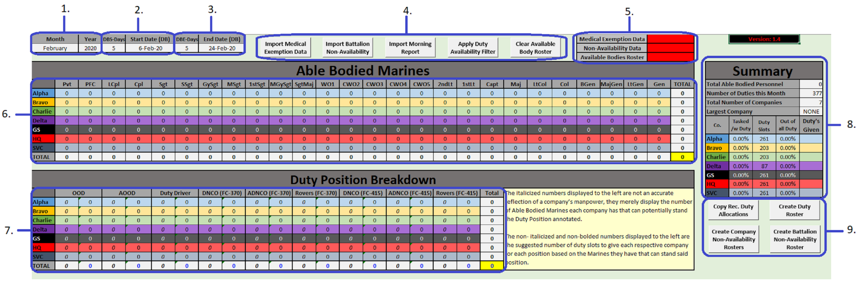Below you can see the layout of the A.B.R.R., each section, and what their purpose is.

1. This is where you choose the month and year that the Duty Roster is going to be created for. The year is required to determine which day of the week a date is as well as which years are leap years. This information allows the roster shown on the “*MASTER*” sheet of the Duty Roster to be properly displayed. Additionally, the other rosters for each building’s duties use this information to automatically highlight the weekends and holidays.
2. This is the Duty Buffer Start date selection. You can use the drop down to under the “*DBS-Days*” to change the date. This date is used to determine who can and cannot stand duty by comparing their start date of medical, leave, T.A.D., non-availability, etc. to the “*Start Date (DBS)*”. It is recommended that the “*DBS-Days*” is never set below 5.
3. This is the Duty Buffer End date selection. You can use the drop down to under the “*DBE-Days*” to change the date. This date is used to determine who can and cannot stand duty by comparing their end date of medical, leave, T.A.D., non-availability, etc. to the “*End Date (DBE)*”. It is recommended that the “*DBE-Days*” is never set below 5.
4. This is the Import/Filter button section. There are five buttons, “*Import Medical Exemption Data*”, “*Import Battalion Non-Availability*”, “*Import Morning Report*”, “*Apply Duty Availability Filter*”, and “*Clear Available Body Roster*”. The buttons are oriented in order of processes, this means that if you have all three rosters filled out and ready to be imported, you can click each button from left to right to import and filter the rosters to create and filter the “*Available Bodies Roster*” located on the “*Available Bodies*” sheet. Each Import button will verify the structure of the expected document prior to actually importing any data. If a document is unable to be verified or is not set up as expected, you will be notified what happened and how to fix it, likewise, the filter button has a similar error check.
   1. The “*Import Medical Exemption Data*” button will search for, detect, verify, open, import, and then close the document with the medical exemption information. Once the process has completed, the date and time of the import will be displayed in the Medical Exemption Data Storage Indicator section. If the file cannot be found or is not verified, you will be notified and informed on how to fix it.
   2. The “*Import Battalion Non-Availability*” button will search for, detect, verify, open, import, and then close the document with the non-availability information. Once the process has completed, the date and time of the import will be displayed in the Non-Availability Data Storage Indicator section. If the file cannot be found or is not verified, you will be notified and informed on how to fix it.
   3. The “*Import Morning Report*” button transfer the stored data from the medical exemption roster and/or non-availability roster then it will search for, detect, verify, open, import, and then close the document with the morning report information. After importing the information, any duplicates will be removed as well as any personnel that cannot stand duty based on the preselected parameters. Once the process has completed, the date and time of the import will be displayed in the Available Bodies Roster Data Storage Indicator section. If the file cannot be found or is not verified, you will be notified and informed on how to fix it.
   4. The “*Apply Duty Availability Filter*” button will apply filters to the Available Bodies Roster on the “*Available Bodies*” sheet and remove any additional personnel that don’t/can’t stand duty for reasons such as rank, legal hold, etc.
   5. The “*Clear Available Body Roster*” button will clear all stored data and rosters in the A.B.R.R.
5. This is the Data Storage Indicator section. When you import the medical exemption roster, non-availability roster, and/or morning report, each respective Data Storage Indicator will change from red to green and contain the date and time that the data was stored. This will allow users to see if certain information is stored within the A.B.R.R. and how recently that information was stored. If the Medical Exemption or Non-Availability Data Storage Indicators are orange, that means that the data was imported, but after the filters were applied, there was no data to use.
6. This is the Able Bodied Marines chart. It is only populated after the morning report has been imported. It displays how many Marines of each rank each company has according to the information currently in the “*Available Bodies Roster*” located on the “*Available Bodies*” sheet.
7. This is the Duty Position Breakdown chart. Similar to the Able Bodied Marines chart, it is only populated after the morning report has been imported and uses the information currently in the “*Available Bodies Roster*” located on the “*Available Bodies*” sheet along with other data to calculate the numbers it displays. It has two columns per duty position, the first is displayed in *italics* and represents the number of Marines that can potentially stand that duty position. The second number is in regular font style and displays the suggested number of allocations to give that company for that duty position. It is important to understand that the italicized number is not an accurate reflection of manpower as one corporal can be counted multiple times since they can theoretically stand multiple duty positions due to their rank and the rank requirements of each duty position. The primary purpose of the italicized numbers are to use in the calculation process to determine how many spots of that particular duty position to allocate to each company.
8. This is the Summary section. It is a brief summary of all the information displayed in the rest of the document. While most of it is self-explanatory, some parts require a more detailed explanation. There are four different columns per company, “*Tasked /w Duty*”, “*Duty Slots*”, “*Out of all Duty*”, and “*Duty’s Given*”.
   1. The “*Tasked /w Duty*” column displays a percentage showing how much of that company is being tasked with duty.
   2. The “*Duty Slots*” column displays how many duty slots out of the total number of duties in that month that the company is responsible for and can potentially stand.
   3. The “*Out of all Duty*” column displays percentage of the “*Duty Slots*” that company is being allocated.
   4. The “*Duty’s Given*” column displays the total number of duty slots being allocated to that company.
9. This is the Roster creation button section. There are four buttons, “*Copy Rec. Duty Allocations*”, “*Create Duty Roster*”, “*Create Company Non-Availability Rosters*”, and “*Create Battalion Non-Availability Roster*”.
   1. The “*Copy Rec. Duty Allocations*” button simply transfers the total number of recommended duty allocations per company from the Duty Position Breakdown chart to the “*Duty’s Given*” columns so that you can tweak the numbers if necessary.
   2. The “*Create Duty Roster*” button should be among the last buttons you click in the A.B.R.R. as it takes all required data from the A.B.R.R. and creates a new Duty Roster for the month with that data.
   3. The “*Create Company Non-Availability Rosters*” button will create a new non-availability roster for each company.
   4. The “*Create Battalion Non-Availability Roster*” button will merge each company’s non-availability roster into one Battalion non-availability roster which can then be imported into the A.B.R.R.

**Duty Roster Features**

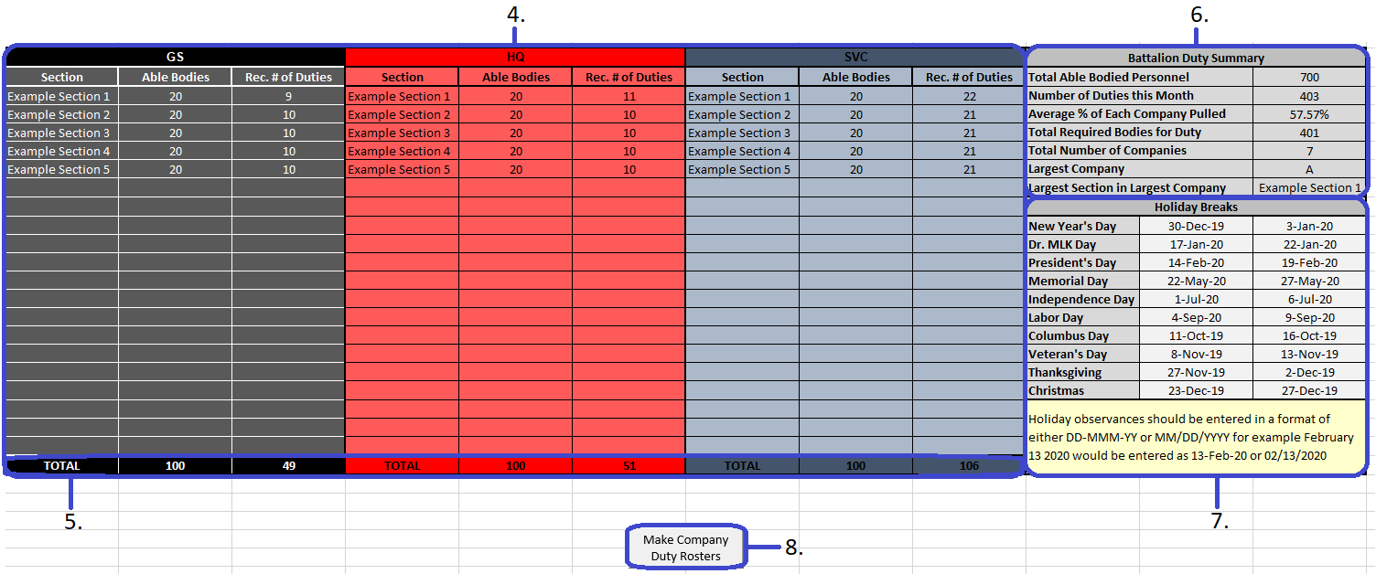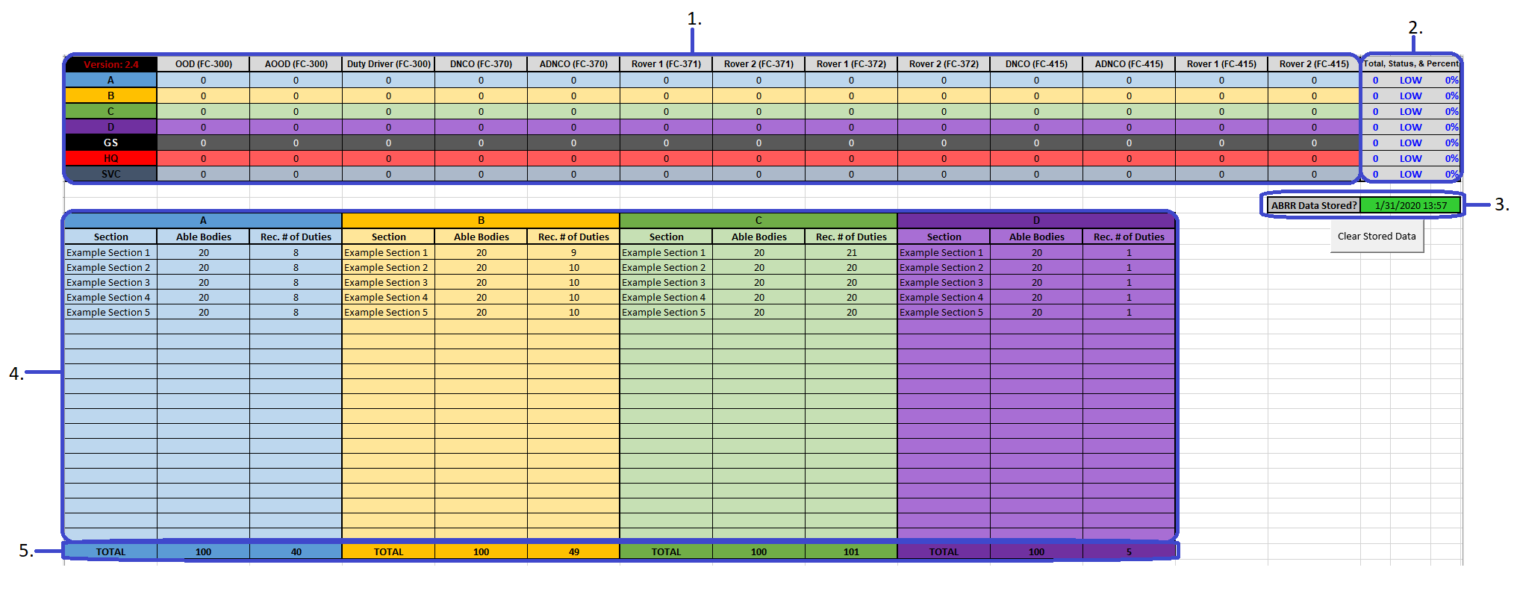Below you can see the layout of the Duty Roster, each section, and what their purpose is.

1. This is the Duty Position Breakdown Chart. This displays the how many duties of each position each company has been allocated.
2. This is the Duty Allocation Summary section. This will display the total number of duties that the company has been tasked with, whether that company’s total number of duties are accurate based on the stored data from the A.B.R.R., and what percentage of the Duty Roster that company makes up.
3. This is the A.B.R.R. Data Storage Indicator. This will turn green if it has stored data from the A.B.R.R. and will display the date and time that the information was stored. This allows the user to see how relevant/recent that stored data is.
4. This is the Company Breakdown section. This is for each company to edit and adjust based on how many sections they are made up of. Both the “*Section*” and “*Able Bodies*” are unlocked and can be edited. This will allow each company to input each of their sections into the “*Sections*” area. Then in the “*Able Bodies*” section, they can enter how many personnel each section has who are physically capable and available to stand duty. Using that information, in addition to the stored data from the A.B.R.R. they can see how many duties to allocate to each of their sections.

If a company is having difficulty determining each section’s number of Available Bodies, they can go to the “*AB Roster*” sheet and use the “*Company*”, “*Platoon*”, and “*Full Unit Code*” to find how many Marines from each section have been determined as capable of standing duty for that month based on the algorithms and calculations of the A.B.R.R.

As each section has a number of Able Bodied Marines entered into the “*Able Bodies*” section, the number of recommended duties for each section in that company will recalculate and be displayed in the “*Rec. # of Duties*” area.

The number of recommended duties per section is calculated by dividing the number of duty positions the company is tasked with by the number of sections with Able Bodies, which provides the duty allocation average. Then dividing the total number of that company's Able Bodies by the number sections with Able Bodies in that company to find the company's average able bodies per section. Finally the duty allocation average is divided by the company's average able bodies per section to determine what percentage to pull from each section.

In cases where the company’s total recommended duties does not match what the stored A.B.R.R data suggests, the section with the largest Able Bodies will be altered by either increasing or decreasing their number of recommended duties. In most cases this addition/subtraction is only by 1, but in more extreme cases it can be by 2.

1. This is the Company Breakdown Total section. This shows the total number of Able Bodied Marines as entered into the “*Able Bodies*” section of the Company Breakdown section. It also displays the total number of duties that the respective company is tasked with.
2. This is the Battalion Duty Summary. This area provides a quick reference of summaries for all of the data in the Duty Roster. Most parts are self-explanatory except for possibly the “*Average % of Each Company Pulled*”. The “*Average % of Each Company Pulled*” is a rough generalization displaying the average percentage that each company is tasked with duty. This percentage is calculated by taking the sum of each company’s percentage that is used to determine that company’s number of recommended duties per section, then dividing it by the total number of Companies.
3. This is the Holiday Observance Tracker. This is where you can edit the Holiday Observances for the year as they are released by Headquarters Marine Corps. These dates are referenced by each sheet that has a roster to ensure that holidays are highlighted yellow in addition to the weekends. The dates must be entered in with the noted formats otherwise the documents will not be able to recognize them as dates.
4. This is the Duty Roster Split/Merge Button. This is where the “*Make Company Duty Rosters*” and “*Make Battalion Duty Roster*” buttons are located. After making the Company Duty Rosters, the button will be replaced with one that will allow you to merge the rosters into one Battalion Duty Roster.

**Using the Able Body Report Roster (A.B.R.R.)**

**Part 1:** Creating the Company Non-Availability Rosters

1. Start by opening the A.B.R.R. and select the month that you would like to make the Duty Roster for, then in the cell next to the month, type in the year.
2. Now that a month and year are determined, you need to adjust the Duty Buffer dates. These dates are used to determine who can and cannot stand duty based on their start and end dates in each roster that will be imported. You can adjust these dates by using the dropdown lists under “*DBS-Days*” and “*DBE-Days*”. If someone’s start date is prior to the determined “*Start Date (DB)*” and their end date ends after the determined “*End Date (DB)*”, they will be filtered out during the import process of each roster.
3. Once you have decided which dates should be used as the Duty Buffer Dates, you can create the Non-Availability rosters for each company. This is simply done by clicking on the “*Create Company Non-Availability Rosters*” button located in the Roster creation button section below the Summary section to the right in the A.B.R.R.
4. Once the A.B.R.R. has finished creating the rosters for each company, a message will appear telling you where to find the rosters. Email the non-availability rosters to the company office for each company and have them fill them out and return their non-availability roster. It is important that the file names and structure are not altered. Ideally, each company office will type in all of the information, however more often than not, people will attempt to copy and paste information, and in doing so might unknowingly alter the cell’s format or imbed links from the document they copied from to the non-availability roster.
5. After each company has completed their non-availability roster and sent it back, save it to the same location that they were created in and replace the originals. **It is imperative that the rosters maintain their original naming standard and structure that they were created with.** If there are any rosters that were not filled out for any reason, the A.B.R.R. will automatically detect that the roster has no viable data and skip it. After each company has returned their completed non-availability roster, open the A.B.R.R. and merge each roster into a battalion non-availability roster. This is accomplished by clicking on the “Create Battalion Non-Availability Roster” button located in the Roster creation button section below the Summary section to the right in the document.

**Part 2:** Importing Rosters and making Calculations

1. Now that you have a battalion non-availability roster, you can begin to create the duty roster. Start by importing the medical exemption roster and battalion non-availability roster. This is accomplished by clicking on the “*Import Medical Exemption Data*” and “*Import Battalion Non-Availability*” buttons located in the Import/Filter button section towards the top center. Neither roster is required to continue; however, they ensure accuracy so that only those who can stand duty are used for the calculations. The source files will be checked prior to importing the data in an attempt to ensure that the documents have the necessary information and that no issues occur during the import process. You will be notified if the verification process finds anything that could cause problems, as well as how to fix it.
2. After importing the medical exemption roster and/or the non-availability roster, the respective data storage indicators will change from red to green and will have the date and time that the information was stored. The stored information is hidden as some of it can be considered Personally Identifiable Information (PII).
3. Only after you have imported the medical exemption roster and/or the non-availability roster, or are purposefully omitting them, should you attempt to import the morning report roster. When you import the morning report, the stored information is added in a specific order then duplicates are removed to ensure that anyone who is on the medical exemption roster and/or non-availability roster who cannot stand duty is removed from the morning report, then removed from the overall roster as well. Furthermore, the previously stored data will be removed from the A.B.R.R. and the data storage indicators will be cleared. Finally the “*Available Bodies Roster*” will be populated with everyone from all three roster who are physically able to stand duty, and the Available Bodies Roster Data Storage Indicator will turn from red to green and have the date and time that the “*Available Bodies Roster*” was created.  
     
   ***NOTE:*** *If the medical exemption roster and/or non-availability roster are imported again after the “Available Bodies Roster” has been created, the Available Bodies Roster Data Storage Indicator will change from green to orange to bring attention to this fact.*
4. After the “*Available Bodies Roster*” has been created, the Able Bodied Marines chart and the Duty Position Breakdown chart will populate with a breakdown of how many Marines of each rank each company has and how many Marines each company has that can stand each duty position. These number are based on the information in the “*Available Bodies Roster*”; however, the roster still needs to be filtered for Marines who cannot stand duty for reason such as legal hold, are of a rank that is not expected to stand duty, etc. Ensure that you apply the Duty filter by clicking on the “*Apply Duty Availability Filter*” button located in the Import/Filter button section towards the top center.

**Part 3:** Adjusting the Numbers and Creating the Duty Roster

1. Once you have applied the Duty Filter, the Able Bodied Marines chart and the Duty Position Breakdown chart will change again to reflect the changes made to the “*Available Bodies Roster*”. While the calculations usually require no additional tweaking, occasionally they might be off by one or two. This can be seen if any of the Duty Position Breakdown chart numbers are either blue or red. If they are red, they are too high, likewise blue indicates they are too low. To fix this, click the “*Copy Rec. Duty Allocations*” button located in the Roster creation button section below the Summary section to the right in the document. This will copy each company’s total duty allocations to the “*Duty’s Given*” column in the Summary section where it they can be edited as necessary.
2. Now you can adjust the numbers, if necessary, to ensure accuracy. For example, if the “*OOD*” total is blue, meaning it is too low, you can find which company has the least number of allocations for that position and increase that company’s total duty allocations by 1. Similarly, if the “*OOD*” total is red, meaning it is too high, you can see which company has the largest number of allocations for that position and decrease that company’s total duty allocations by 1. After you have made the necessary adjustments to the “*Duty’s Given*” and the Total cell highlighted yellow in the Duty Position Breakdown chart is displayed in green numbers, you can create the duty roster. Whether you need to make adjustments or not, you still have to click the “*Copy Rec. Duty Allocations*” button before creating the new duty roster.
3. When you make a new duty roster, you will be asked if you want to keep the A.B.R.R. open for reference, this is in case you want to use the Duty Position Breakdown chart to show you how many of each position to give each company, rather than jumping back and forth between the building roster and the Summary sheet on the Duty Roster.

**Part 4:** Allocating Duty Positions, and Creating and Merging Company Duty Rosters

1. Now that you have a Duty Roster created with the necessary data imbedded in it from the A.B.R.R., you can begin to allocate each duty position to the companies. The easiest method of doing this is by keeping the A.B.R.R. open and using the numbers from the Duty Position Breakdown Chart to know how many of each positon to give to each company.
2. After you have allocated all duty positions to the companies in the newly created duty roster, go the “*Summary*” sheet and ensure that “*Total, Status, and Percentage*” on the Duty Position chart is green for each company. If a company’s “*Total, Status, and Percentage*” is either red or blue, then they have too many or too few duty allocations when you were assigning duty positions to each company. Make sure you adjust as necessary, and ensure that the “*Total, Status, and Percentage*” is green for all of the companies before continuing.

**NOTE:** *If adjustments to the “Duty’s Given” were made prior to creating the Duty Roster, then then “Total, Status, and Percentage” may not be green despite having perfectly matches what was in the A.B.R.R.*

1. Any Duty Roster created with the A.B.R.R. should have data stored in it from the A.B.R.R. as indicated with the A.B.R.R. Data Storage Indicator. Additionally, each company has their own area on the “*Summary*” sheet where they can enter the name of each section that falls under that company, and how many Marines they have who can stand duty. These sections should be filled out by each company to ensure that no one section is being tasked with duty any more or less than the other sections based on their total numbers. For as long as the Duty Roster has information stored from the A.B.R.R., each company can accurately utilize their area and see how many duties to give each section.
2. Once all duty positions have been allocated to the companies, you can scroll down and click the “*Make Company Duty Rosters*” button to duplicate the Duty Roster and rename each duplicate per company. Then you can email the Company Duty Rosters to the company office for each company and have them fill them out and return them. It is important that the file names and structure are not altered.
3. After each company has filled out and returned their duty roster, save it to the same location that they were created in and replace the originals. **It is imperative that the rosters maintain their original naming standard and structure that they were created with.** Once you have all of the Duty Rosters back and have replaced each of the originals, open the Duty Roster that was used to make the Company Duty Rosters and merge each roster into a Battalion Duty Roster. This is accomplished by clicking on the “*Make Battalion Duty Roster*” button located in the same spot as the “*Make Company Duty Rosters*” button was. Your Duty Roster is now finished and can be sent out to each company.